Electrostatics Homework 1 (35 Points + 6 Extra Credit)
(jas, Electrostatics HW 1.docx, 10/23/2025)

Use units and clearly label answers using 3 or 4 significant digits where appropriate. Show your work so that if necessary partial credit can be awarded.

- Calculate the number of electrons flowing past a given point in a wire per second for a current flow a 1 Amp. (2 points.)
$$A=C/s$$
$$1C=6.242* {10}^{8} e$$
1 A = $6.242* {10}^{8}\frac{electrons}{second}$

- Based on the atomic structure of copper atoms, describe the actual charge transfer associated with current flow in a copper wire when the wire is connected across a small batter such that one end of the wire is connected to the positive terminal of the battery with the other end connected to the negative terminal of the battery. Include the type of charge carriers, the direction of charge transfer and a description of the charge transfer into and out of the wire. (Use your own words and at least three complete sentences for your answer). (6 points.)

Copper has one valence electron, in its outer shell. That means that copper is a good conductor, because the electrons can move freely from one atom to the next. When a voltage is applied, the electrons (negative charge) move from negative to positive. At the negative terminal of the battery, the electrons move into the battery, and at the positive terminal of the battery, the electrons move into the copper wire.

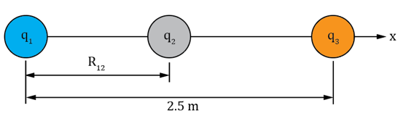
- Three point-charges in air are shown in the adjacent diagram with Q₁ = 2.2 C, Q₂ = -1 C and Q₃ = 3 C. Determine the distance required between Q₁ and Q₂ so that the net electrostatic force on Q₂ = 0. For this auto-graded question, use at least 3 significant figures for your answer not using scientific (engineering) notation. (Hint: The resulting distance is between 1 and 1.5 m.) (6 points.)

$$F_{12}=F_{23}$$
$k\frac{\left|Q_{1}Q_{2}\right|}{{r_{12}}^{2}}=k\frac{\left|Q_{2}Q_{3}\right|}{{r_{23}}^{2}}$
$$r_{23}=2.5-r_{12}$$
$k\frac{\left|Q_{1}Q_{2}\right|}{{r_{12}}^{2}}=k\frac{\left|Q_{2}Q_{3}\right|}{{(2.5- r_{12})}^{2}}$
$$\frac{\left|Q_{1}Q_{2}\right|}{{r_{12}}^{2}}=\frac{\left|Q_{2}Q_{3}\right|}{{\left(2.5- r_{12}\right)}^{2}}$$
$$\frac{{\left(2.5- r_{12}\right)}^{2}}{{r_{12}}^{2}}=\frac{\left|Q_{2}Q_{3}\right|}{\left|Q_{1}Q_{2}\right|}$$
$$\frac{\left(2.5- r_{12}\right)}{r_{12}}=\sqrt{\frac{\left|Q_{2}Q_{3}\right|}{\left|Q_{1}Q_{2}\right|}}$$
$$\frac{2.5}{r_{12}}-1=\sqrt{\frac{\left|Q_{2}Q_{3}\right|}{\left|Q_{1}Q_{2}\right|}}$$
$$\frac{2.5}{r_{12}}=\sqrt{\frac{\left|Q_{2}Q_{3}\right|}{\left|Q_{1}Q_{2}\right|}}+1$$
$$r_{12}=\frac{2.5}{\sqrt{\frac{\left|Q_{2}Q_{3}\right|}{\left|Q_{1}Q_{2}\right|}}+1}=\frac{2.5}{\sqrt{\frac{3}{2.2}}+1 }=1.15 m$$
$$r_{12}=1.15 m$$

- Using MATLAB find the electric field E located at R = [0, 3, 1] for a 4 µC charge located at R1 = [5, 2, -1] and a -2 µC charge located at R2 = [-3, -1, 4], for ε = ε₀ = 8.85 X 10⁻¹² F/m. (Hint: The resulting x component magnitude is approximately 1370 V/m.)
(8 Points.)
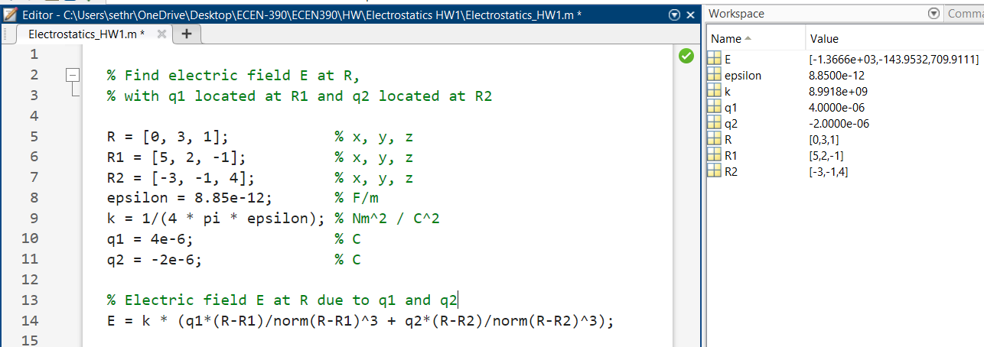

$$E=\left[-1370, -144.0, 710.0\right] V/m$$

-1.3666 -0.1440 0.7099

- Using the expression for electric field $\text{E = }\frac{Q}{4πεR^{2}}\hat{R},$outside of a hollow air-filled conducting sphere of radius 0.1 m having a surface charge Q $=$ 2.2 nC, with R being the distance from the center of the sphere:
- Determine the magnitude of E at a distance R = 1 meter from the center of the sphere. (2 points.)
$$E=\frac{Q}{4πϵ_{0}R^{2}}=\frac{2.2*{10}^{-9}}{4π\left(8.85*{10}^{-12}\right){\left(1\right)}^{2}}=19.78 V/m$$
$$E=19.78 V/m$$

- Determine the magnitude of E for a point inside the hollow air-filled conducting sphere. (2 points)

Gauss’s Law:
$$\oint{Dds=Q}$$
$D=ϵE→ \oint{Eds=\frac{Q}{ϵ}}$
Since Q is an enclosed surface, the surface integral is 0.
E = 0

- Using the expression for electric field $\text{E }\text{=}\frac{ρ_{s}}{2ε}\hat{z} \left(\hat{z} is unit normal vector\right)$ for an infinite sheet of charge with a surface charge density $ρ_{s}=$ 100 pC/m² and ε = ε₀ = 8.85 X 10⁻¹² F/m:
- Determine the magnitude of E at a point P above the sheet. (2 points.)

$$E=\frac{100*{10}^{-9}}{2*8.85*{10}^{-12}}=5.65\frac{V}{m}$$
$$E=5.65 V/m$$

- Determine the magnitude of E for a point twice as far above the sheet as point P.
(2 points.)
$$E=\frac{100*{10}^{-9}}{2*8.85*{10}^{-12}}=5.65\frac{V}{m}$$
$$E=5.65 V/m$$

The electric field at a point above the infinite sheet is the same. This is because as you rise up, there are more parts of the sheet whose fields align at an angle that doesn’t cancel out, but also decreases with distance. Thus the magnitude of the field at any point is the same.
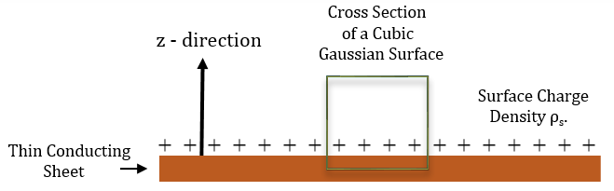
- A thin conductive sheet suspended in air with a surface charge density of $ρ_{s}$ on the upward facing surface is illustrated in the adjacent figure. Utilizing the cubic Gaussian Surface shown in the figure, with each face of the cube having surface area A, answer the following questions:

- Determine the charge enclosed by the Gaussian surface in terms of $ρ_{s}$ and A.
(2 points.)

$ρ_{s}$is measured in $\frac{C}{m^{2}},$so charge per surface area. Since the cube intersects the thin sheet, and is parallel to the surface, the charge enclosed in the surface is
Q $=ρ_{s}A$

- Starting with the integral form of Gauss’s law in terms of D, determine an expression for the electric field intensity E for a point in the positive $\hat{z}$ direction above the conducting sheet, including the steps involved. Your answer for E is to include a unit vector for completeness. Note: Assume an electric field intensity of zero inside the conductor. (3 points. 2 points for including at least 2 steps.)

Gauss’s Law:
$$\oint{Dds=Q}$$
Using $D=ϵE$:
$$\oint{Eds=\frac{Q}{ϵ}}$$
A Because of the pill box, the only surface where any electric fields pass through is the top surface. So,
$$E∙A=\frac{Q}{ϵ}=\frac{ρ_{s}A}{ϵ}$$
$$E=\frac{ρ_{s}}{ϵ}\hat{z}$$

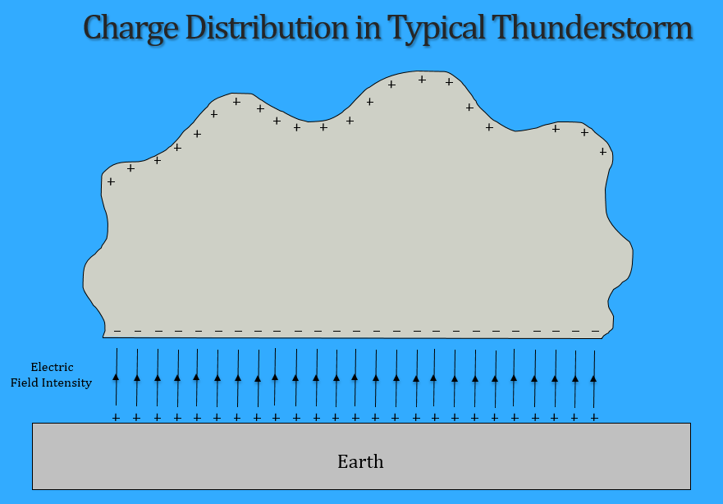
Extra Credit Problem: (6 points total.)
A simplified thundercloud and associated charge distribution is portrayed in the adjacent illustration. The resulting electric field between the cloud base and the induced charge on the earth’s surface results in an approximately uniform electric field between the cloud and ground for commonly observed flat based electrified clouds.

- Assuming a cloud base height of 3 km above the earth’s surface in the above diagram, calculate the associated potential difference (voltage) including sign of the cloud base relative to the earth (ground) assuming a uniform electric field of 5 kV/m. (2 points.)
$$E=5kv/m;l=3000 m$$
$-\int_{P_{1}\left(earth\right)}^{P_{2}\left(ground\right)}{Edl}=-\int_{0}^{-3000}{Edl}=-\left[El{\left.​\right|}_{0\left(l\right)}^{3000}\right]=-\left[E\left(3000\right)-E\left(0\right)\right]$
$$\left[5\frac{kv}{m}\left(3000\right)-E\left(0\right)\right]=-15000 V= -15kV$$
$$V=-15 kV$$

- Calculate the theoretical air dielectric breakdown voltage magnitude from the cloud-base 3 km above the ground assuming an air breakdown strength of 2 MV/m.
(2 points.)

$$V_{br}=E_{ds}d=\left(2*{10}^{6}\frac{V}{m}\right)\left(3000 m\right)=6*{10}^{9} V$$
$$V_{br}=6*{10}^{9} V$$

- Hazardous cloud-to-ground lightning discharges can occur for electric field magnitudes as low as 3 kV/m, whereas air breakdown strength is on the order to 2 MV/m. In your own words, comment on this discrepancy using at least two complete sentences. (See Lighting Initiation Problem.) (2 points.)

Usually the field across air needs to be at 2 MV/m, but when lightning strikes it can be much lower. This doesn’t make intuitive sense, almost like the insulator is being turned into a conductor. Theories say that this is because of the charged ice and water particles in the cloud, or even cosmic rays. But in reality, we don’t know much about why or how this happens.

